EXPERIMENT-11

PROCEDURES

Aim:

* Create a table with attributes students and marks.
* Insert values into the table.
* Create a procedure to get the merit students (marks > 50).
* Create a procedure to get marks of a given id (using in).
* Create a procedure to display highest marks (using out).
* Create a procedure to get marks of a given id (using in and out).
* Create a table with attributes students and marks.



* Insert values into the table.
* 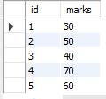
* Create a procedure to get the merit students (marks > 50)

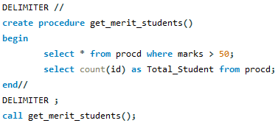

* Create a procedure to get marks of a given id (using in).

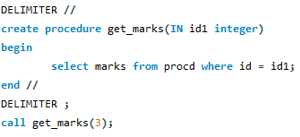



* Create a procedure to display highest marks (using out).

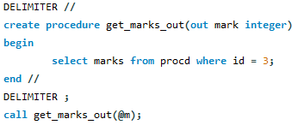



* Create a procedure to get marks of a given id (using in and out).

